JetMach Trainer 60

Aerobatic turbine trainer for small (14 lb) thrust turbines

Wing Span 80 In
Wing Area 1300 Sq In
Weight (dry) 15.5 Ib

Fuselage length 75”
One or Two piece wing
Uses standard servos.

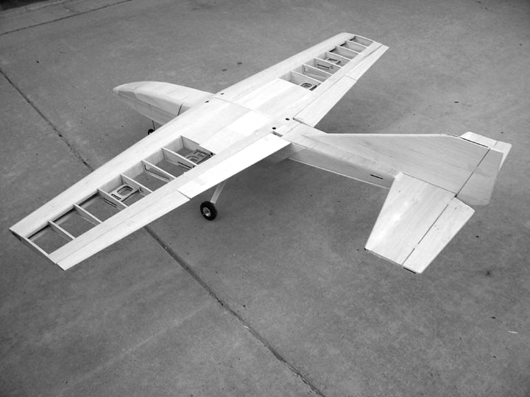

Warranty…… Laser Design Services L.L.C. guarantees this kit to be free of defects in both material and workmanship at the date of purchase. This warranty does not cover any component parts damaged by use or modification. In no case shall Laser Design Services L.L.C.’s liability exceed the original cost of the purchased kit. Further Laser Design Services L.L.C. reserves the right to change or modify this warranty without notice.
In that Laser Design Services L.L.C. has no control over the final assembly or material used for final assembly, no liability shall be assumed nor accepted for any damage resulting from the use by the user of the final user-assembled product. By the act of using the user-assembled product the user accepts all resulting liability.
If the buyer is not prepared to accept the liability associated with the use of this product, the buyer is advised to immediately return the kit in new and unused condition to the place of purchase.

Safety Precautions

This radio controlled model is not a toy.

Experienced modelers should have no
difficulty during the construction and flying of this JetMach design.

Construction and flying of this model is not recommended for beginners.

Turbine powered models are for advanced flyers only.

READ THROUGH THIS INSTRUCTION BOOK FIRST, BEFORE BEGINNING ASSEMBLY.

A construction photo CD is included.

Hardware List

Tower Hobbies part number are given for reference, note that the package may contain more parts than you will need. Check your local hobby store .

Tower part # | Hardware | package per plane | Quantity per plane
G.P. LXK196 | Nylon boltsx4 | 1 | 4
LXD866 | Pushrod Cover(18) | 0.16 | 3
LXE007 | 1/4-20 Cap screw | 0.5 | 2
G.P. lxk079 | 4-40 Clevisx12 | 0.58 | 6
G.P. lxk085 | 4-40 clevis solderx12 | 0.58 | 6
Ex: robart LXET42 or use fiberglass horn | Control horn Ail/elx2 | 2 | 4
Ex: Robart LXET43 or use fibeglass horn | Control horn Flapx2 | 1 | 2
Dubro LXD871 | 4-40 pushrod 6"x6 | 1.16 | 6
Dubro LXD874 | 4-40 pushrod 30"x24 | 0.0833 | 2
Dubro LXD858 | P-P assy | 1 | 1
Dubro lxd972 | 1/4-20-blind-nutsx4 | 1.5 | 6
Aileron and flap control horn bolts | 2-56 x 1.25 |  | 12
G.P. LXK110 | CA hinge(24) | 1 | 24
Dubro LXD843 | Nose gear | 1 | 1
provided | Rudder horn | 1 | 1

50 Oz tank
3” main wheels with brakes
2” nose wheel
UAT ( or make your own)
Hatch Latch

JetMach Trainer 60 Assembly Instructions

Use suitable glue, I use aliphatic wood glue ("Titebond" carpenters glue) for most every thing, it adheres to plywood the best. you have to wait for it to dry though, or use thin and thick C.A.

Foaming polyethylene (Gorilla glue) is used for the wing blocks and wing tube. Silicon glue is used for the heat shield.

Cover the plans with wax paper to protect them when gluing.

Make sure you have a flat surface, weights, T-pins and clamps with at least a 6” capability available and the glue

Place a check mark at each construction point as you build.

Remove the parts from the laser cut sheets and bag the like parts. Note that some wood has been left to secure the parts in place, Use a sharp blade to free the parts where necessary.

Note: test fit all parts before gluing

On a Flat work surface:

Wing Assembly

Note, I used aliphatic glue for the wing assembly.

Right Wing

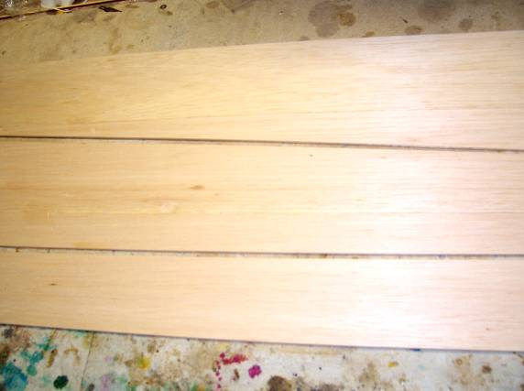
Wing sheeting.

Glue three piece of the 3/32 sheeting together, make sure that the edges are straight, lay on a wax paper covered flat surface and tape together using masking tape, flip over, fold the sheet towards the masking tape, run a bead of aliphatic glue along the join, fold back together, wipe off the excess glue and pin down, repeat for each wing. Sections can be stacked with wax paper between each.

Cut the wing sheeting from 3/32 balsa to the shape on the plan, make four sets.

Make sure that the piece that is left over is the length of the balsa- 42”, to be used for the trailing edge sheeting

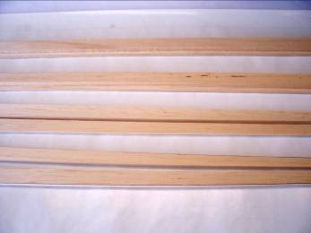
Wing leading edge

Cut the leading and trailing edges from 1/4 in sheet, two sets. Laminated the two leading edge pieces, pin on a flat surface...

Laminate ribs 1 and 1-a and 1-1 and 1-1a, making sure that they are aligned.

Laminate the wing bolt mount plates, four sets; laminate the wing tube support doublers to ribs 2 to 5, note that the wing tube support doublers are not symmetrical. Make a right and left hand sets

Clean any glue residue from the wing tube holes and wing bolt mount holes, and trial fit the wing tube, and the wing bolt mounts in their slots.
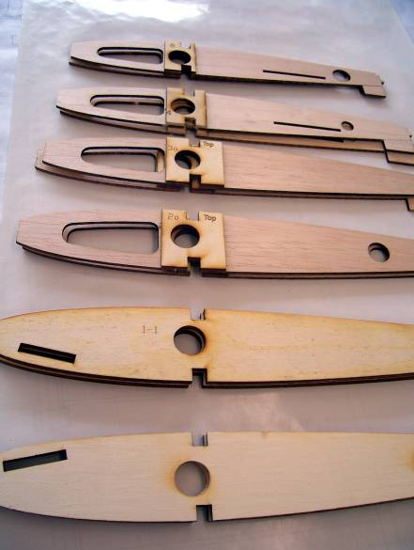
Laminated ribs.

Cut the two pieces of trailing edge sheeting from 3” 3/32 sheet. And two pieces from the piece left over from the leading edge sheeting.

On a flat surface, cover the plans with wax paper, cut to length and pin the 3/8 sq spar to the plan, ensure that the spar is straight and aligned on the plans.
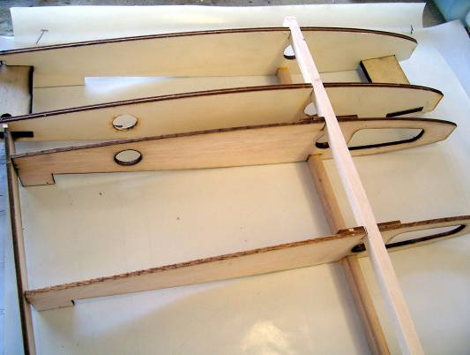
Wing assembly.
.

Locate the dihedral alignment gage. Note that the top of the wing is flat when both sides are assembled upside down and the rib taper will result in a positive dihedral.

Position the ribs on the plan with the tabs down.

Glue rib #1 to the spar; align with the dihedral gage with the arrow pointing up.

Glue the rest of the ribs to the spar in place over the plan, making sure that the ribs are aligned and vertical and the rib tabs are in contact with the plan.

Cut the top spar to length and glue in place; make sure that the dihedral angle is set.
.
CA Glue the laser cut 1/8 trailing edge and leading edge to the ribs, ribs are tabbed to fit into the leading and trailing edge of the ribs.

Glue the 1/4 in trailing edge in place, sand even with the 1/8 trailing edge.

Glue the wing mount plate with epoxy, in the slots in Ribs1 and 1-1; note the location of the wing mount holes
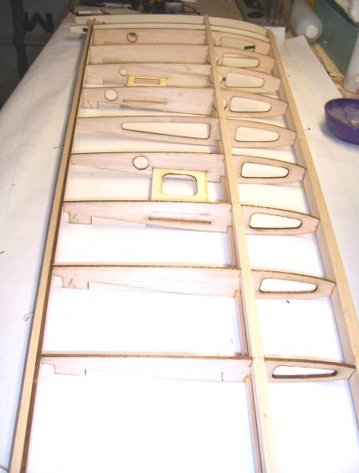 Wing assembly

Trial fit the wing tube.

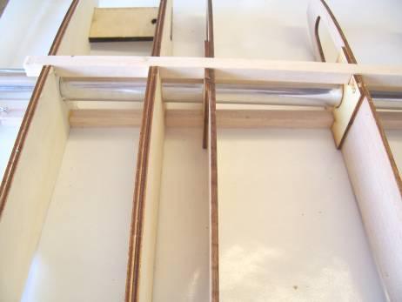 Wing tube fit.

Cut the shear webs from 3/32 sheet and glue the shear webs in place between ribs 5 and 9, the shear webs are even with the top of wing spars, the grain of the shear webs must be vertical
Let dry completely.
For the Two piece wing, glue shear webs all the way to the root rib. The shear web at the root is made of 1/8 lite ply and should be a good fit to the root rib. Glue the wing bolt retention doubler pieces to the inside of the root rib; install the ¼-20 T-nut.

Roll and Install a paper tube thru the holes in the ribs for the servo wires, tack glue in place
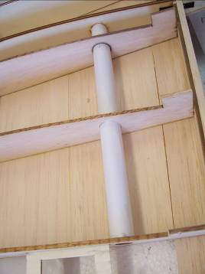 paper tube

Cut the 3” 3/32 sheet in two 1.5” pieces. Glue the3/32 trailing edge sheet even with the rear of the 1/4 trailing edge

Position the top leading edge sheeting in place, the rear of the sheeting should align with the rear of the top spar, glue sheeting to the main spar and to the leading edge, when dry trim the sheet leading edge. Alternatively, glue the laminated leading edge to the laser cut leading edge, make sure that the leading edge is 3/32 above the ribs, Position the top leading edge sheeting in place, the rear of the sheeting should align with the rear of the top spar, trim the sheeting to fit the laminated leading edge, glue sheeting to the main spar, ribs and leading edge.
Note: that spraying the top surface sheeting with water will aid in curving the sheeting.

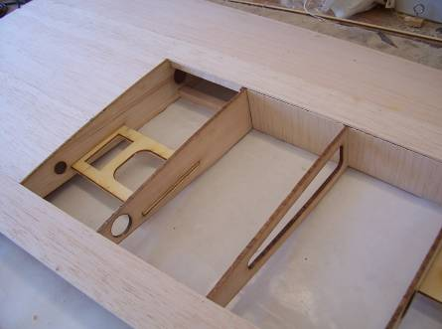

NOTE: Do not install and glue the sheeting between ribs 1 to 4 and the leading and trailing edge.
.
Let the glue dry completely, and then turn the wing over to work on the bottom. The wing will still be flexible at this point.

Drill through the wing mount holes perpendicular to the wing mount plates, and the top sheeting to locate the wing mount holes

Remove the wing rib tabs.

Sand the ¼ in trailing edge even with the 1/8 trailing edge.

To ensure the correct wing incidence, pin the trailing edge securely to the plans, the wing must be held down to the plans with weights on the ribs behind the spar, with the trailing edge sheeting and the leading edge sheeting resting on the plan. The work surface must be FLAT

Cut the left over 3/32 sheet from the leading edge sheeting in two pieces. Glue the 3/32 trailing edge sheet in place

Cut and glue 1/4 scrap to fill the gap between the wing mount plates and the top of the rib at the location of the wing mount holes. Sand the balsa to conform to the rib this is required to resist the force exerted by the wing bolts

With the following step the wing will start to become rigid, make sure the wing is held securely to the plans.

Position the bottom leading edge sheeting in place, the rear of the sheeting should align with the rear of the top spar, glue sheeting to the main spar and to the leading edge, when dry trim the sheet leading edge. Alternatively, Position the top leading edge sheeting in place, the rear of the sheeting should align with the rear of the top spar; trim the sheeting to fit the laminated leading edge, glue sheeting to the main spar, ribs and leading edge.

If required, Glue the 1/4 in leading edge to the ribs and 1/8 leading edge even with the top and bottom sheeting

Glue the 3/32 wing sheeting between rib 1 and rib 4 and the leading and trailing edge.

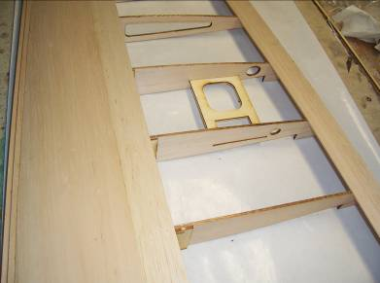

Glue the liteply servo mounts in the slots in the ribs, orientate as per the plans, add the reinforcing doublers where servo screws are located.

Glue the covering support on top of the ribs in line with the servo mounts. At the flap servo, cut and glue from scrap 1/8 sheet, a support for the bottom wing sheeting. Glue to the inside of the rib and level with the top of the rib.

Drill the wing mount holes through the bottom sheeting, enlarge the wing mount holes in the top sheeting to 1 in dia to accept the wing bolts, make a paper tube to fit in the holes to restrain the wing bolts

Cut and glue the ¼ x 3/32 cap strips to the ribs.

Round the leading edge to an airfoil shape, refer to the plans for the correct shape; sand the wing sheeting, wing tips etc.

Put the incomplete wing aside and build the left wing following the above instructions.

Wing alignment

Glue a ¼ in locating dowel in the alignment hole in one of the wing root ribs

Decide whether to build a one-piece or two-piece wing

One-Piece Wing

Abrade the wing tube with 100 grit sandpaper

Lay the two wing halves upside down on a flat surface and join with the wing tube and alignment dowel, the wing top surface must be flat and the root ribs in alignment, when satisfied with the alignment, a apply foaming polyurethane (Gorilla Glue) to glue the wing root ribs together, secure the wing in place and glue the wing tube to the ribs with foaming polyurethane glue (Gorilla Glue). To position the glue, move the wing tube a small amount from the ribs, to place the glue, move the wing tube sideways a little, place the glue, move the tube back and rotate the wing tube to distribute the glue. Clamp the wing root ribs together. Cure overnight

Glue the 3/32 wing sheeting between rib 1 and rib 4 and the leading and trailing edge

Sand the wing sheeting

Complete the wing assembly

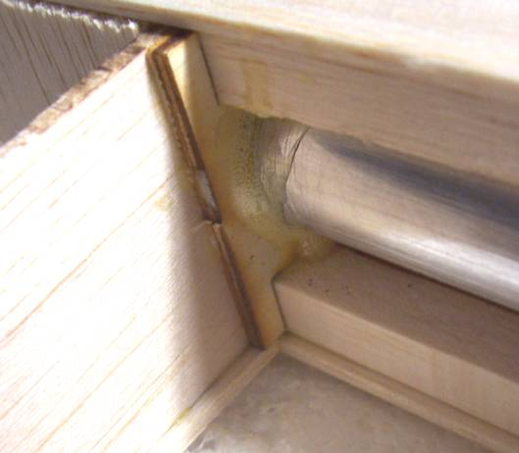 Wing tube glue joint

Two-Piece Wing

The wing is held together by a ¼-20 nylon bolt, this is to ensure that the root ribs are clamped together and that the wing loads are transferred evenly to the wing tube. The wing tube must be a tight fit to the wing ribs.

Ensure that the shear webs have been glued to the ribs, along to the root rib as detailed previously.
Glue the bolt doublers to the inside of the root ribs, make sure that the doubler is a good fit to the 1/8 ply shear web and the root rib.
Install the t-nut to one side
Test fit the wing tube, and bolt
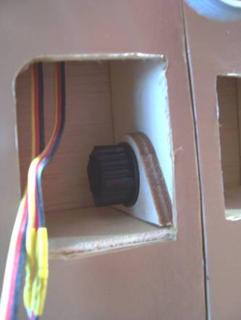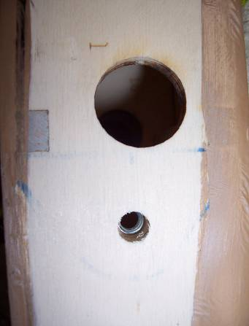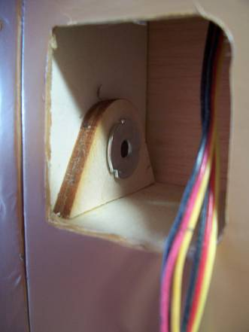
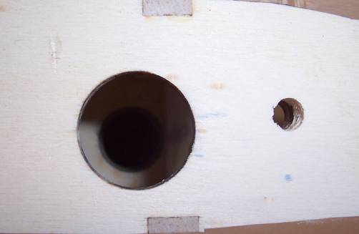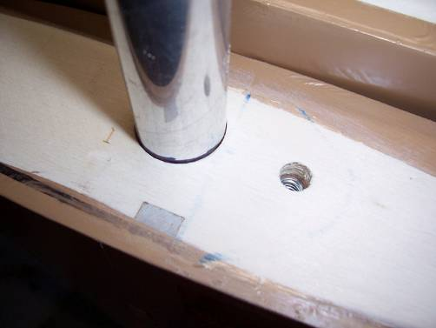

Glue the 3/32 wing sheeting between rib 1 and rib 4 and the leading and trailing edge.
Cut a hole to access the wing bolt and servo leads, both sides.

Sand the wing sheeting

Flaps and Ailerons

Pin the 3/32 flap and aileron pieces to the plans. Sand the ¼ in leading edge pieces at an angle as shown on the aileron/flap section drawing. Glue the leading edge in place, using the sub ribs to set the correct angle, glue the flap/aileron sub ribs in place.

Glue scrap ¼ in pieces for the control arm, as shown.
Sand leading edge level with ribs

Glue the top 3/32 aileron/flap pieces.

Sand ends to the size shown on the plans and add 1/8 sheet caps to close surfaces.

Verify the alignment and thickness of the flap/ailerons, to the wing and sand as required.

Ailerons sand the top and bottom surface smooth, round the rear edge, sand and plane a 30 Deg bevel to the leading edges.

Flaps are hinged at the bottom surface and must have a small gap when in the up or neutral position to eliminate any servo stalling in the up position, sand as required.

Fuselage

Laminate: clamp each piece until dry.

F2a to F2
F-4's
F-5's
Engine mounts

Make sure that you make a right and left hand fuselage side,.

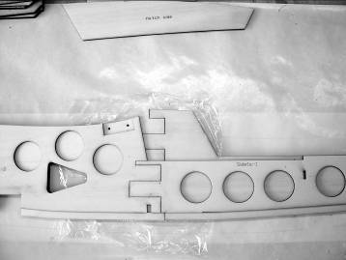 fuselage joint

On wax paper, glue each of the side 1 tongue and grooves together, should be a tight fit, use a block of wood to ensure joint is flat,, place a piece of saran wrap between the two sides at the joints, make sure both are aligned the same and weight them down on a flat surface to dry.

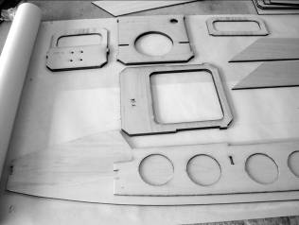

Lay one glued side 1 on a flat surface, align the side 2 doublers, align the doublers using the triangular air inlet as a guide and glue in place, weigh down, when dry, flip over, and build the second side on top of the first, this will ensure a left and right hand side. (Fig 1) and the side alignment, or build them side by side.
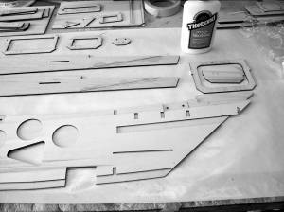

Lay a completed side on a flat surface, slot and glue F-4 and F-5 in place, place the other side on top, glue and slot in place. Make sure formers are perpendicular to the sides. To ensure fuselage alignment, place the fuselage upside down on a flat surface, resting on the wing opening, clamp the sides together and weight down and let dry.
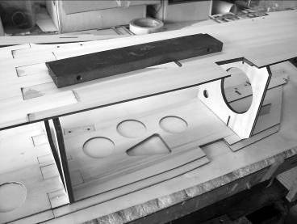

Lay the fuselage on bottom, glue "rear fuse bottom" in place (Fig 3), IMPORTANT. Make sure it is seated on the lower edge of the fuse doublers and even/flush with the rear of F-5, this is essential for the alignment of the rear fuselage. Clamp the rear of the fuselage to conform to the "rear fuse bottom".
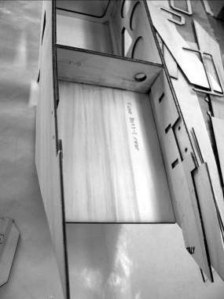

Glue engine mounts in slots in F-5 and fuse doublers, arrow points to fuse outer side
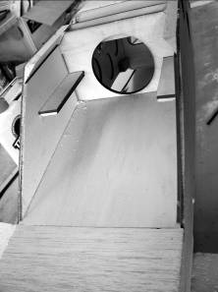

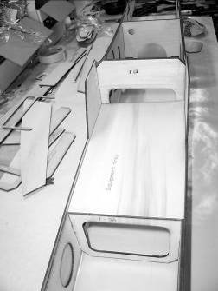

Trial fit F-3 and the equipment tray; this will ensure the forward fuselage alignment.

Glue F-3, with the equipment tray in place; do not glue the equipment tray. (Fig 4)

Drill nose gear holes in F-2

Install the nose gear mount to the rear of F2

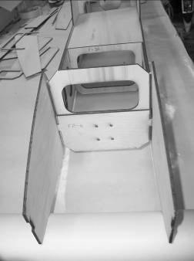

Install and glue F-1 and F-2, using the battery compartment floor for alignment
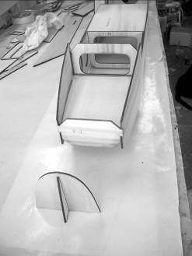

View fuselage from front to check alignment, when satisfied; glue the battery compartment floor in place.

Glue the nose formers together, glue assembly to F-1.

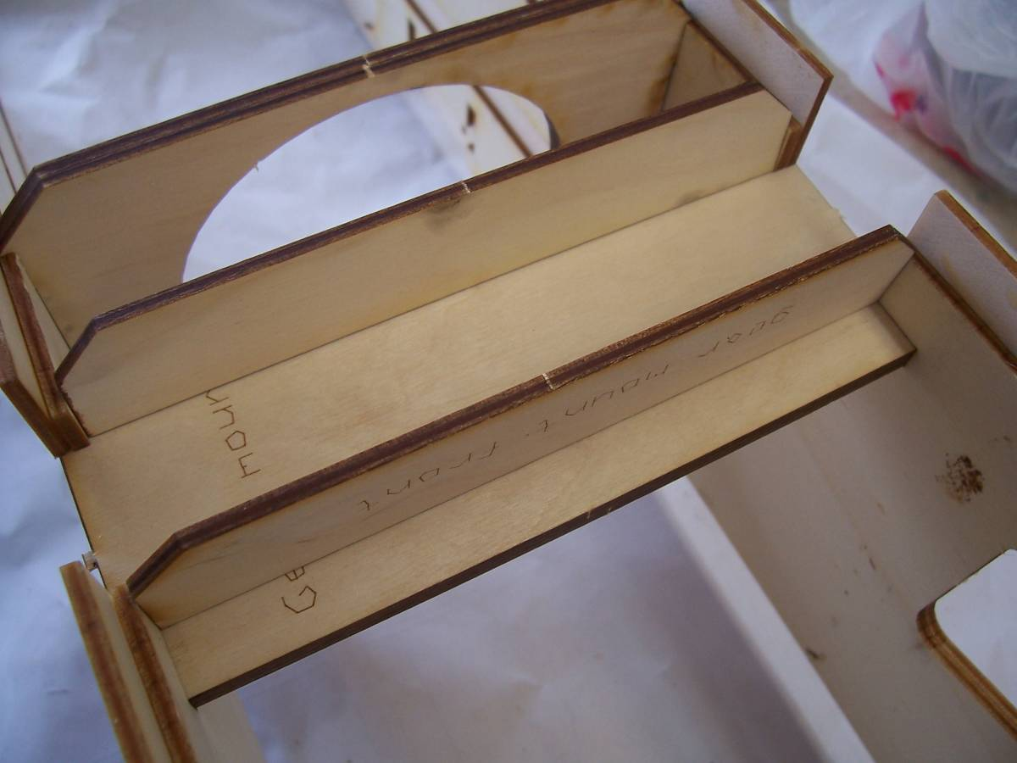

Sand the edges of the gear mount where it will be glued. Epoxy the gear mount in in slots in fuselage sides. Align and glue the plate support formers with the opening in the fuselage sides.
I used 30 min epoxy and add milled fiberglass until the mixture won't run. Glue securely. The gear mount can also be reinforced with scrap basswood on the inside of the fuselage.

Rear fuselage

Make a right and left hand side

A set of sides made of lite-ply are provided. Use these if you plan to put the elevator servo’s at the rear. Laminate the servo opening reinforcing pieces and modify the triangular stock to fit.

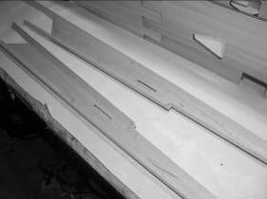

Cut the 1/2 in triangular strip, two pieces ", two pieces 33", two pieces 18 3/4” and two pieces 8.5”.

Join the two rear fuselage side pieces, together

Glue the triangular pieces to the rear fuselage sides (Fig 7), the 33” piece to the bottom edge, ensure the triangular stock is even with the rear fuselage sides. Pin to a flat surface

Sand the stabilizer mount area flat.

Place the forward fuselage on its bottom, slide the two rear fuselage pieces in place to check the fit, the bottom triangular stock is flush with the " rear fuselage bottom", the top triangular stock is flush with the fuselage top, overlap joint must be aligned with no gap.

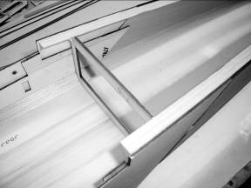

Locate F-8 in place and rubber band the rear of the fuselage to hold fuselage sides together.
This will ensure the alignment of the rear fuselage.
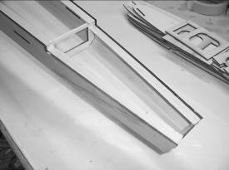
Pin in place and view fuselage from the front, place a straight piece of wood across the rear stabilizer location and check that it is horizontal. When satisfied with the alignment, glue the front of the rear fuselage securely in place with aliphatic glue or C.A. to the fuse sides, and the “rear fuselage bottom”

Glue F-8

Glue F-6 at the rear of the "rear fuselage bottom" and to the fuselage sides.

Glue F-7 in front of the horizontal stabilizer location.

Servo Mounts

Measure and cut the 1/4” basswood to length to fit the three servo mount locations. Glue in position at the bottom of the slots, note that the mounts need to be angled to be installed.

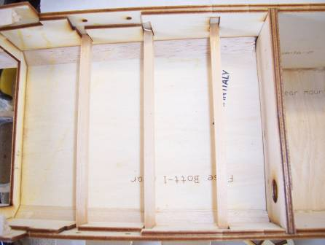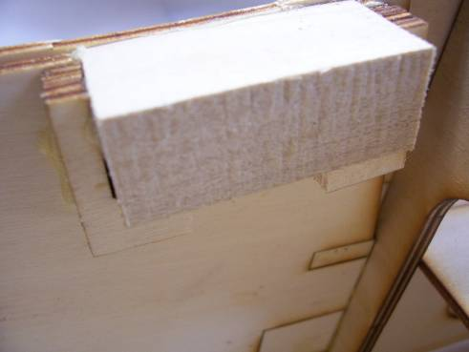

Wing Mount Blocks

Laminate eight pieces of the wing block doublers for each wing block , the rear doublers are marked. Note that the wing blocks are tapered to allow clearance for the wing dihedral, the top and outside is marked. Glue and clamp the wing blocks and doublers to the fuselage sides securely, use foaming polyurethane glue or slow cure epoxy, the top of the wing block is level with top of the fuselage side .

Note: You may also choose to drill thru the 1/8 holes, peg and glue with 1/8 dowels or C.F.

Hatch

Make a right and left side.

Glue bottom strips to the lower edge of the hatch sides.

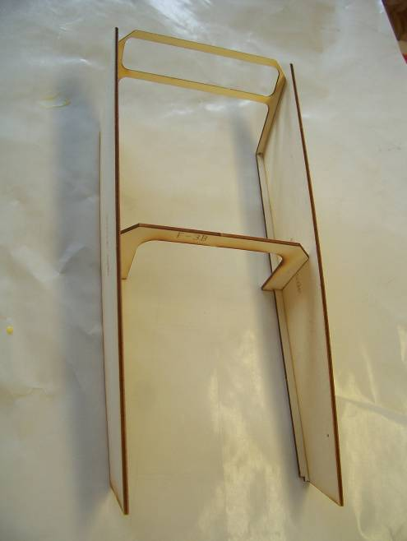

Mark the position of F-3 on the hatch sides, glue F-3 and rear hatch former to hatch sides,

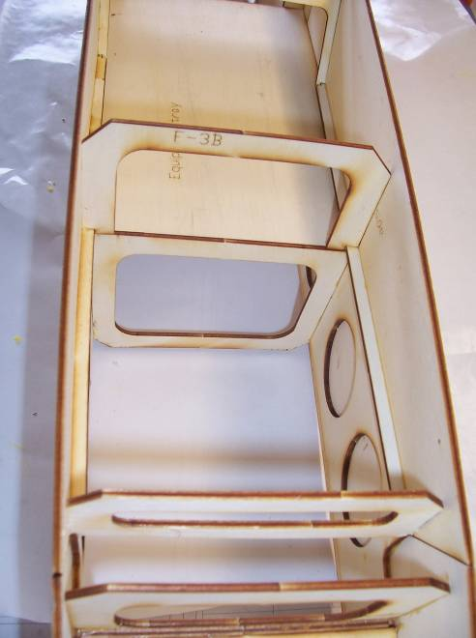

Locate the hatch on the fuselage. Adjust the width of front hatch former if necessary to ensure that the hatch is flush with the fuselage sides and glue the front hatch former to the hatch sides.

Tape the hatch in position on the fuselage, flush with fuselage sides.

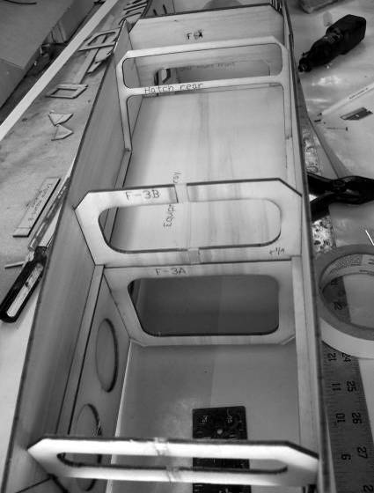

Fuselage

Cut the 1/2 in triangular stock to length, from F-4 to F-1, glue to fuselage, hatch and formers, both sides.

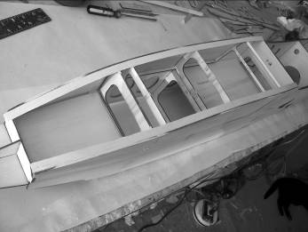

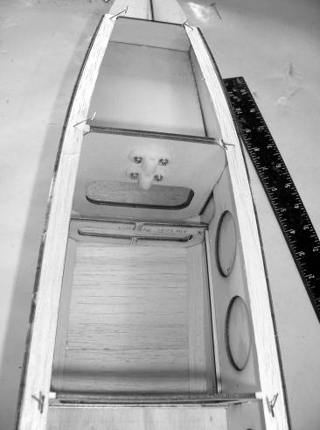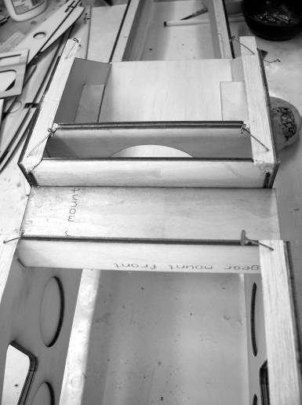

Cut the 1/2 in triangular stock to length, from the gear mount to F-1 and from the rear of the gear mount to the end of the fuselage, glue to fuselage, and formers, both sides.

Sand the triangular strips flush with fuselage sides.

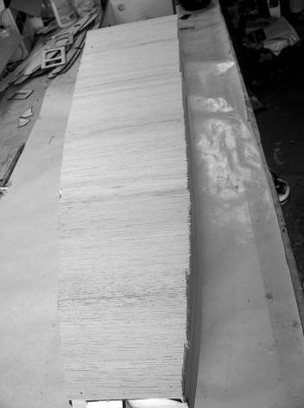

Glue the 1/8 sheet "cross grain" to the to fuselage top.

Glue the 3/32 sheet "cross grain" to the to fuselage bottom from the main gear mount forward.

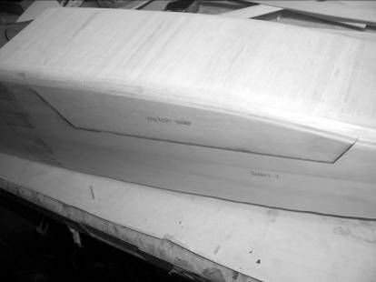

Sand the corners of the fuselage to a round section. I used a belt sander with 60 grit; a sanding block with 60 grit will get the job done with some effort.

Using a hard backed razor blade, cut the hatch free from the triangle stock and the 1/8 sheet.

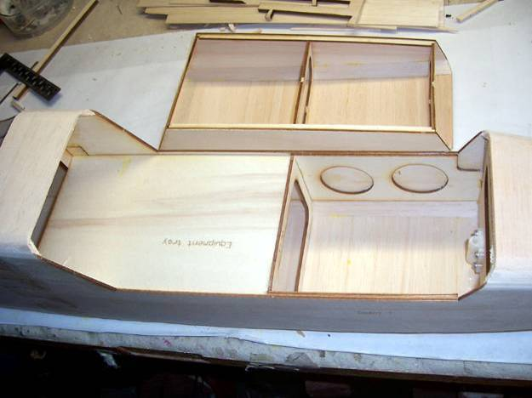

Sand front and rear of hatch.

Glue the hatch location tabs to the front and rear, the top of the front tabs should be in line with the triangular fuselage corners to retain the hatch

Install the rear hatch retaining latch, made or purchased, make the latch pin retaining block from scrap lite ply and glue to the hatch rear. drill to suit.

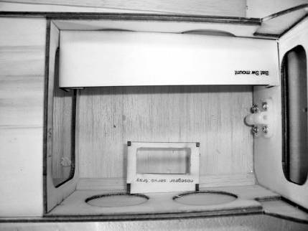

Assemble the nose gear servo mount and glue to the right fuselage side, as shown.

Cut the battery tray mounts from basswood, and glue to the right or left fuselage side (Left side shown).

Place the main gear to the center of the main gear cutout in the bottom of the fuselage and symmetrical with the fuselage centerline, mark the retaining bolt locations and drill a ¼ in hole at each location. Enlarge the holes to fit the ¼ in T-nuts, install T-nuts

Glue the 1/8 sheet cross grain to the fuselage top, from the rear of the wing mount to the front of the stabilizer mount, sand the corners to a round section.

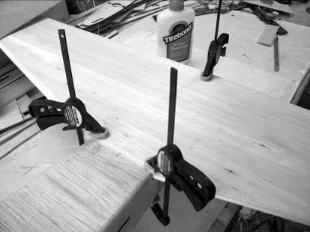

Horizontal Stabilizer

Laminate the 1/8 balsa stabilizer parts

Cut two sets of the 1/8 sheet to the shape of the stabilizer using the plans as a guide, glue the three pieces together.

On a flat surface

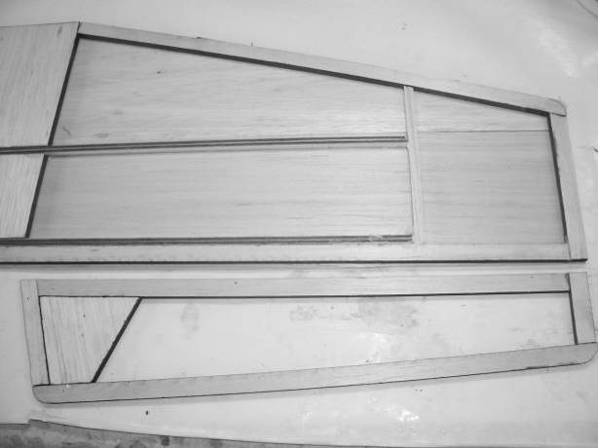
Cut the 48in 1/4in Sq basswood stick into two 24in parts.

Pin the 1/4in Sq basswood to the plans, cut the 1/4 x 1/2in and 1/4in Sq balsa for the stab using the plans as a guide, pin and the parts to the plan and glue. Pin and glue the 1/8 sheet to the stab parts on the plan, weigh down and let dry.

Glue the other 1/8 sheet to the other side. Weight down and let dry. (Fig 13)

Sand the top and bottom surface smooth, sand the rear edge flat, round the leading edges

Elevators

Laminate the 1/8 balsa elevator parts

Cut the 1/4 x 1/2in balsa for the elevator using the plans as a guide, pin and glue the parts to the plan.

Pin and glue the 1/8 sheet to the elevator parts on the plan, weigh down and let dry. Glue the 1/8 sheet to the other side, weigh down and let dry.

Sand the top and bottom surface smooth, round the rear edge, sand or plane a 30 Deg bevel to the leading edges.

Vertical Stabilizer

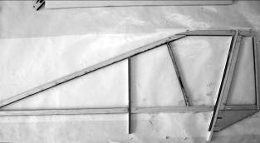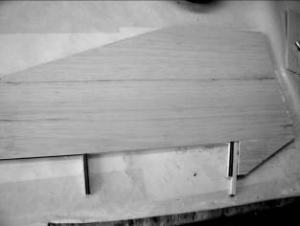

Cut two sets of the 1/8 sheet to the shape of the stabilizer using the plans as a guide, glue the two pieces together

Cut the 1/4in Sq basswood stick to length from the plans.

Pin the 1/4in Sq basswood to the plans, cut the 1/4 x 1/2in and 1/4in Sq balsa for the stab using the plans as a guide, pin and glue the parts to the plan. Pin and glue the 3/32 sheet to the stab parts on the plan, weigh down and let dry.

Glue the other 3/32 sheet to the other side. Weight down and let dry. (Fig 14)

Cut the rudder loose from the vertical stab.

Vertical stab-Sand the top and bottom surface smooth, sand the rear edge flat, round the leading edge

Rudder-Sand the top and bottom surface smooth, round rear edge, sand or plane a 30 Deg bevel to the leading edge.

Open the slot in the rudder for the push pull rudder arm and test fit the arm in place.

Horizontal Stab

Sand the horizontal stab mount on the fuselage to remove any glue residue, etc.

Place the horizontal stab in place, trim the leading edge, if necessary, such that the rear of the stabilizer is in line with the rear of the fuselage and pin in place.

Lay the vertical stabilizer on top of the horizontal stab with the forward basswood spar in line with the front edge of F-7; note that the basswood will be glued to F-7 at final assembly.

Mark where the rear basswood spars will pass through the horizontal stab and fuselage top sheeting, cut a 1/4 sq hole at these locations.

Slide the vertical stab through the horizontal stab, the forward basswood must be in contact with the front of F-7, there will be a gap between the rear basswood and F-8, adjust the hole on the top fuselage sheeting as required until the vertical stab is aligned correctly. Remove the vertical stabilizer.

Horizontal/Vertical tail Assembly

Align the horizontal stab by measuring from the front of the fuselage to the rear corners of the stab, the distances must be equal, pin in place and mark the stab position, verify that the stab is horizontal to the fuselage.

Remove and glue stab to fuselage, using epoxy, I used 30 min mixed with milled fiberglass. Verify alignment and horizontal position.

Position the vertical fin in place, verify that the front basswood spar is in contact with F-7, and the fin is flush with the horizontal stab and fuselage and aligned with the centerline of the fuselage.

Glue the fin in place, ensure that the fin is 90 Deg to the horizontal stab and aligned with the centerline of the fuselage. Clamp the basswood to F7 to maintain alignment. When dry, securely glue the forward spar to F-7, insert a piece of scrap liteply between the rear spar and F-8 and glue securely.

Nose
Glue the two nose pieces together and glue to F1. To shape the nose fill the space between the formers. I use blue or white foam, sand to shape and fiberglass the nose.
Scrap ¼ in balsa can also be used, shape to fit.

Fuselage

Glue 3/32 sheet cross grain to the bottom of the rear fuselage, sand edges, do not round.

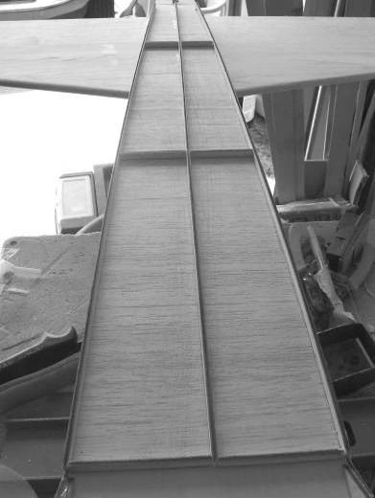

Glue the 1/4 x 1/8, (1/4 in vertical). Sticks to the bottom of the fuselage in the pattern shown, this is the mount for the aluminum heat shielding.

Wing Assembly

Place the assembled wing in place on the fuselage, trim the leading edge at the center to fit in the wing saddle if necessary, mark the center of the fuselage, front and back and align the wing centerline to the marks. Measure from each wing tip to the horizontal stabilizer and ensure that the measurements are equal, tape or pin in place, verify that the wing is aligned horizontally, adjust the wing saddle as necessary.

When satisfied with the alignment, mark the wing mount holes on the wing mount blocks, drill with 1/4 in bit through the holes in the mounting plates into the wing mount blocks, enlarge the holes in the wing mount block to accept the t-nuts, install t-nuts.

Place a piece of Saran wrap around the leading edge of the wing at the center, mount wing with the four nylon bolts, verify wing alignment.
Fill in the gap between the wing and the fuselage with scrap balsa, gluing the balsa to the fuselage.

Remove wing.

Cut a hole in the bottom of the wing, 7in from the rear of the wing and 1.5 in from the wing root for the servo wires on each side.

Thread string to the flap and aileron servos to pull through the servo cables.

Make equipment tray support brackets from scrap basswood and glue to the fuselage sides, install equipment tray

Install the nose gear servo and connect the servo to the nose gear steering arm.

Install the elevator and rudder servos as shown. Note that the rudder servo arm is angled to match the geometry of the rudder control arm.

Note: If desired the elevator servos may be located at the rear of the fuselage just below the leading edge of the horizontal stabilizer. This will result in a shorter control rod and greater stiffness of the elevator control system. But this will result in more nose weight being required.

Slot the ailerons, flaps, elevators and rudder for the C.A. hinges as shown on the plans

Drill the servo mounting holes for the aileron and flap servos, run CA into the holes

Cover the airframe, I used Monokote. Note: do not cover the heat shield area.

Note: to remove the covering material from all the access holes, use a small soldering iron to melt the covering, this leaves a nice neat hole

The fuselage bottom behind the gear mount is left open to provide extra air for the turbine, this opening may be covered with a FOD screen , I prefer to leave this open and have the FOD screen on the front of the turbine

Forward servo installation Install the elevator pushrod tubes and cut to length, do not glue yet. Run the 4-40 control rods and align with the servo arms, mark the position for the elevator control horns on the elevators in
line with the control rods. Install control horns.
Install the threaded clevises and mount to servo arm . Cut the pushrod to length and fit the solder clevis at the elevator.
Make supports for the pushrod covers at the servo end, glue pushrod covers.

Rearward servo installation cut out the opening, install servo, Install the threaded clevises and mount to servo arm . Cut the pushrod to length and fit the solder clevis at the elevator.

For a rigid control horn, I make a fiberglass horn and imbed it in the elevator. Glue sucrely in place.

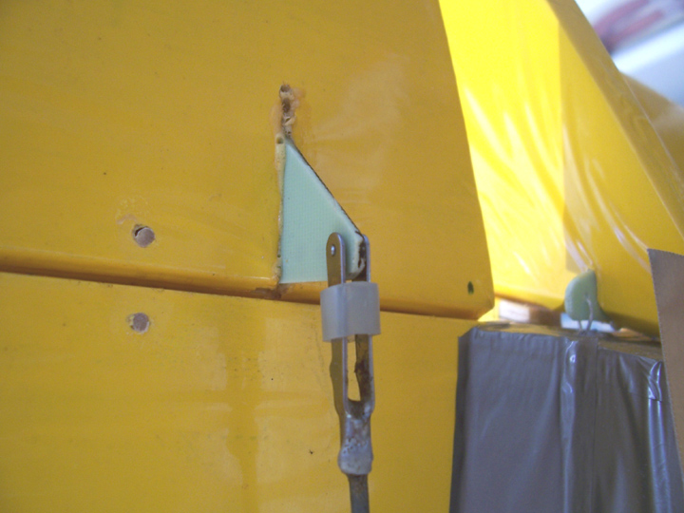

Caution make sure that the elevator control system is slop free and rigid. If this is not assured, high speed flutter of the elevators is possible, resulting in catastrophic destruction of the elevators.

As a solution to eliminate any possibility of elevator flutter, mass balancing of the elevator halves is possible. Add weight forward of the hinge line untill the weight is more than the weight of the elevator. The mass balance is made of aluminum strip with the lead glued in place, secure to the elevator with two cap screws.

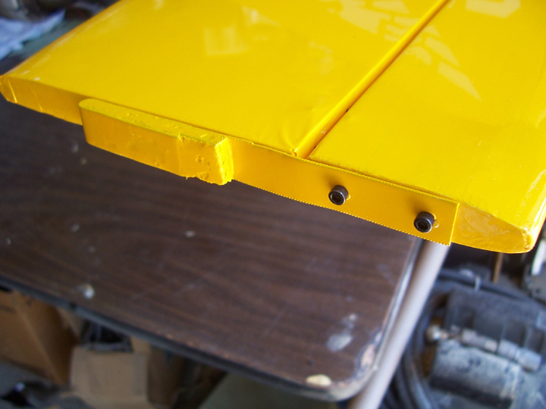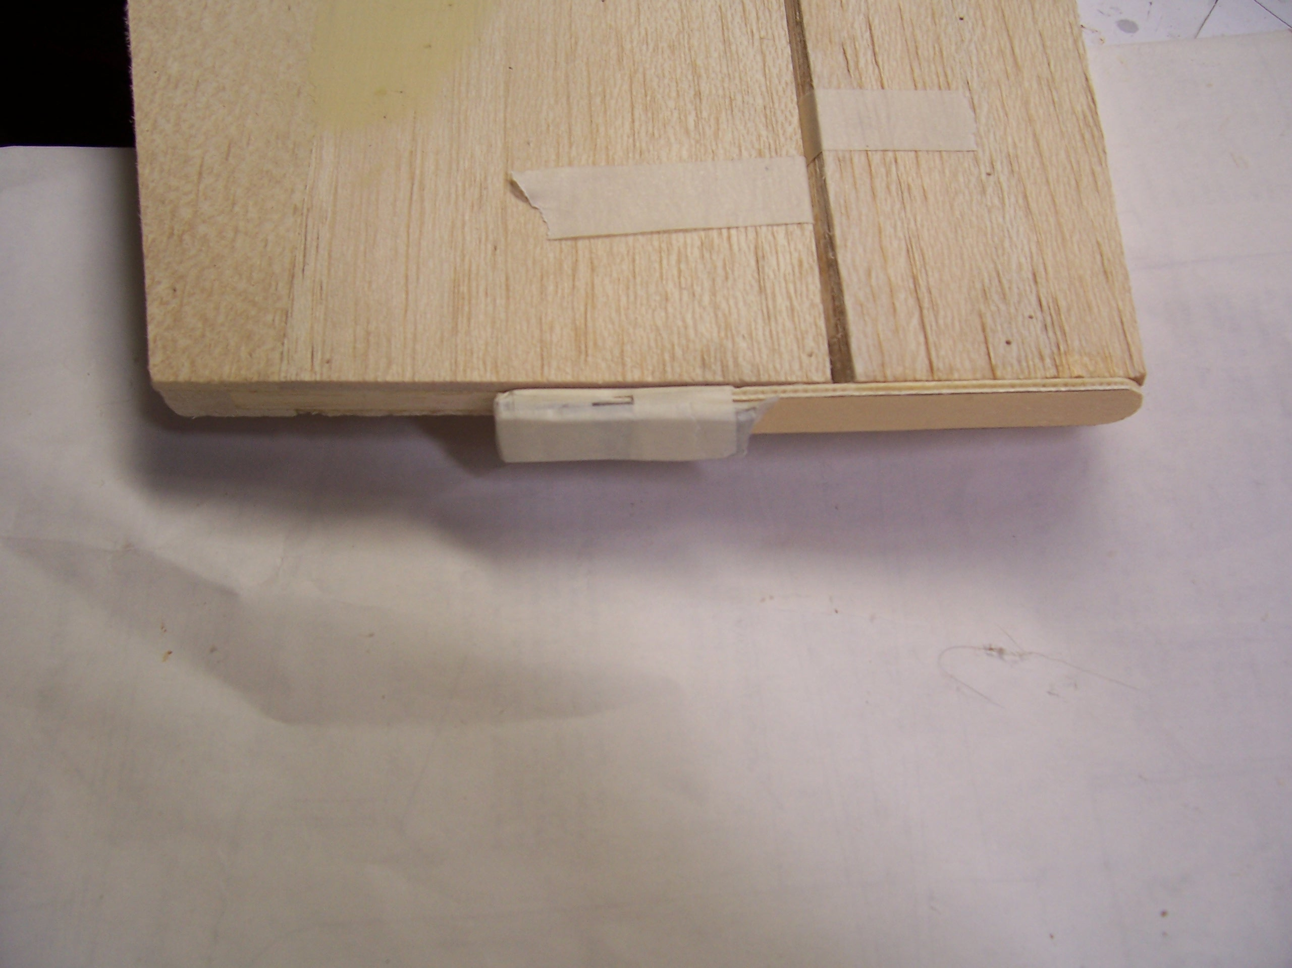
Mass balancing

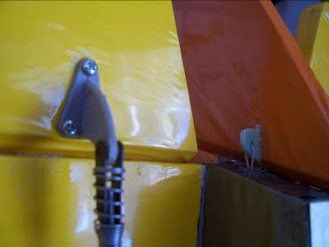

Drill holes in the fiberglass rudder control horn as shown.
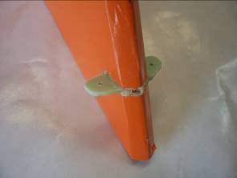

Roughen the surface to be glued. Glue the rudder arm in place. Install pull-pull control system

Place the piece of aluminum on the fuselage rear make sure that the aluminum overlaps forward spacer by the turbine by 1/8 in, this will be bent down to ensure that the air stream will not peel the aluminum off, position the aluminum on the rear fuselage mark the outline of the fuselage on the aluminum, If you wish the sides of the aluminum can be bent up on the outside, this will make the heat shield more rigid and reduce any wrinkling of the aluminum with use, if you choose to do this, then allow ¼” of extra, cut the aluminum to shape, bend the rear 1/8 tab down, bend the sides if required.. Glue the aluminum to the spacers with silicon adhesive, Note if the silicon glue squeezes out leave it till it has cured and the cut off with a sharp blade, less mess this way. Screws may be added, to secure the aluminum for security.

Nose Gear

Install the main wheels to main gear, install main gear to fuselage using ¼-20 bolts. Use 3” diameter wheels for the main, 2” for the nose wheel.

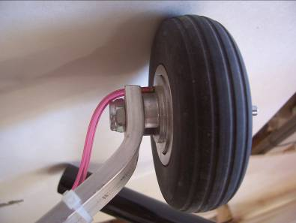

The length of the nose gear and nose wheel needs to be adjusted so that the angle of incidence of the wing is neutral or slightly down.

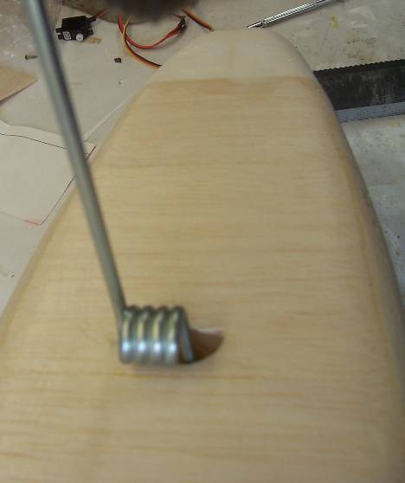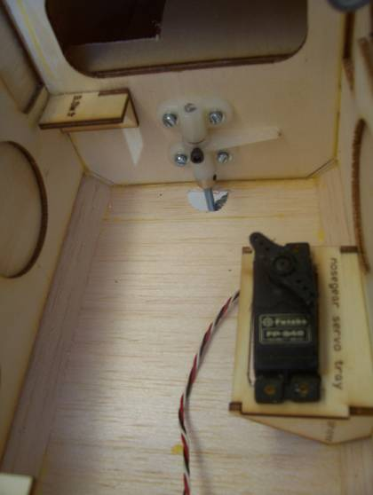

Servos

The JetMach is designed to use 8 standard servos of at least 44 oz/in

Elevator 2
Rudder 1
Aileron I each
Flap 1 each.
Nose wheel 1

I used “Y”’s for the aileron and flap servos, if you choose to do this make sure that the servo arm direction is the same for the flaps and opposite for the ailerons

Center of Gravity

C.G is 5.5” from the leading edge of the wing at the center.

Install as much of the heaviest equipment (batteries, UAT, fuel pump) as far forward as possible, this will avoid the need for adding any nose weight.

Control Surface Deflections

Measure at the trailing edge of the surfaces.

Maximum throws:

Aileron +/- 0.75” measured at flap
Flap - 3” measured at the center section
Elevator +/- 1.25” measured at the rear of the elevator in line with servo control arm
Rudder +/- 1.25”

Set dual rates to suit your flying style, we find that the maximum deflections shown will give smooth flying characteristics, and aerobatic capability. No exponential was used.

Flap programming

Mix approx 7% down elevator with max flap deflection to avoid pitch up with flap deflection.

Radio Installation

Receiver is located in the lower front fuselage by the nose wheel servo.

Antenna is routed through a pushrod tube down the right side of the fuselage.

Turbine Installation

The JetCat P-60 is a drop in fit for the engine mount, other turbines may/will require modification to the mount. If the mount included with your turbine is to large, make a mount with aluminum “L” section and hose clamps, (see the P-70 illustration)

Note A FOD screen on the turbine is highly recommended

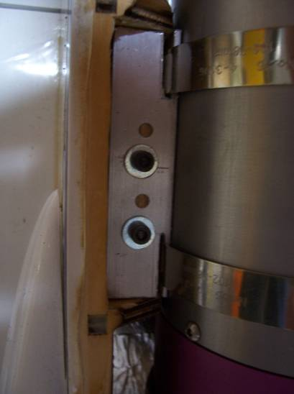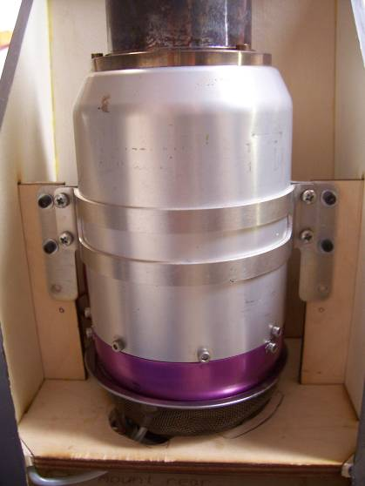
P_70 mounted on a Baby Boomerang P-60

The turbine air inlets are placed well forward of the turbine location, this serves two purposes, one is to avoid weakening the structure around the gear mount, the other is that the opening allows the fuel level in the tank to be seen after landing, we often take off again and go round for a couple of laps, if we can see the fuel level,
Air should be allowed to flow freely, from the intake, around the tank and to the turbine.
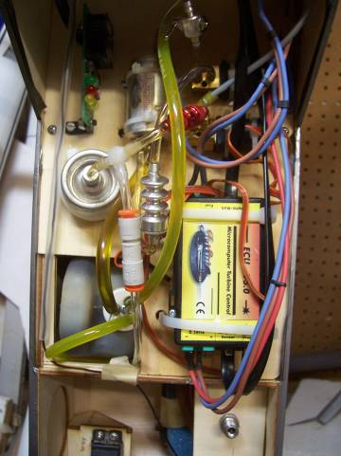

Flying the JetMach:

It is important to note that, although the JetMach is a trainer with stable flying qualities, it is still capable of high speed flight. You must always stay a step ahead of the plane. The plane can cover a great distance quickly.

Takeoff:

You will find takeoffs to be very simple and easy.
Make sure the nose gear is tracking straight.
Line up on the center of the runway and slowly advance the power.
The JetMach will accelerate rapidly and at times will begin to rotate on it's own after about 50ft.
On your first flight, try and keep the nose down and let the plane build up speed on the runway.
You will not need much elevator to become airborne.
Once the plane leaves the ground, you may need to hold a slight touch of DOWN elevator to keep the nose on the horizon. It will quickly gather speed and you can relax to neutral elevator. It will climb on its own.

Very short takeoff's can be accomplished by adding half flap, holding brakes on and bringing the motor up to full power. Once you reach max RPM, release the brakes and hold a touch of UP elevator. The JetMach will be airborne anywhere between 30-60ft.

Flying:

Once you established a comfortable altitude and are trimmed out, you can begin to explore the flight envelope of the JetMach. With a slight headwind and at idle power, the JetMach will fly very slowly, sometimes even appearing to fly backwards.
Stalls are exactly like you would expect. It will just slowly drop its nose and immediately begin flying again. Rolls are very axial and depending on your aileron throw, can be very fast!
Loops track straight and it is capable of very large looping maneuvers.
Slow rolls, spins, stall turns are all very easy to do. Don't be afraid to get this plane slow, it will not bite you.
I have even attempted a hovering maneuver and it almost did it, it’s all about the thrust timing. It just dropped its nose and flew out.

Knife edge flight is limited, depending on the amount of rudder throw. If Knife edge flight is important to you, an increase in rudder area would be required, adding an inch in length to the rudder would not be a problem, and the pull-pull system can handle it, though an increase in servo torque may be required.

Landing:

When you are ready to land, make a pass down final reducing power.
Make your turn and slowly drop in full flaps and reduce power to idle.
Make a descending turn onto final. The trick now is to watch how the plane behaves.
If you to try to level the nose and it want's to climb, then you still have too much speed. If you are a distance still from the runway, this is not a problem and just continue the approach trying to level the nose. Once it levels without climbing, then you are on target. It will slowly descend and decay speed all the way to the runway. It only takes a bit of up elevator to create a nice flare and a greased landing.

If on approach the plane starts getting too slow, just slowly advance power to 1/4 throttle for just a moment, then back to idle. This is good for about 200ft of ground coverage.
On a windy day, you will find that you will need a bit of throttle all the way down to the runway.

Also note that the rudder is very effective on landing. This comes in handy on crosswind days. Don't be afraid to use it. It will straighten out the nose perfectly.

The wing loading of the JetMach is low enough to allow multiple take offs and landings in one flight even with a full fuel load, great for practice, also touch and go’s are very easy.

In the event of a dead stick, just keep the nose level and manage your speed by trading altitude. Make any turns slowly and not abrupt. Only when you are sure you will make the runway, you can go ahead and add flaps. I would not add flaps if the plane is already moving slowly when the dead stick occurred.
If it appears that you just will not be making it to the runway, add flaps if you have enough airspeed, work at keeping the wings level. Slowly begin a flare before it reaches the ground. If it does not balloon, continue adding elevator. In a full flare with full elevator, the plane should only be moving in the 15-20mph range thus lessening the chance of major damage.

Good Luck!

